Software Requirement Specifications

NextStepAI
From Resume to Readiness - Your AI Career Companion

Version: [1.0]

Project ID | F24-63
Supervisor | Yusra Kaleem
Co Supervisor | Saeeda Kanwal
Project Team | Anas Shahid 22K-4513  Hussain 22k-4244  M. Ahmed 22K-4482
Submission Date | 4/12/2025

Introduction

Purpose of Document
The purpose of this Software Requirements Specification (SRS) document is to provide a comprehensive and detailed outline of the functional and non-functional requirements for NextStepAI, an AI-powered career and academic opportunity matching platform. This document serves as the definitive reference for all stakeholders involved in the development, testing, and deployment of the system.
Key purposes include:
- To establish a clear communication framework among students, developers, supervisors, and potential users
- To act as a contractual agreement defining system capabilities and constraints
- To provide a foundation for system design, implementation, testing, and validation
- To ensure requirement traceability throughout the project lifecycle
- To facilitate requirement verification and validation activities
- To serve as a baseline for change management and version control

Intended Audience
This document is intended for:
- FAST NU Administration and Faculty: For project evaluation and academic assessment
- Project Jury Members: For understanding system capabilities and innovation
- Project Supervisor: For guidance, review, and approval of requirements
- Development Team (Anas Shahid, Hussain, Muhammad Ahmed): As the primary implementation reference
- Students of FAST NU: As potential users and beneficiaries of the system
- Quality Assurance Team: For test case development and validation
- Future Developers: For system maintenance and enhancement
- External Stakeholders: Including career counselors, HR professionals, and academic advisors

Abbreviations
- AI = Artificial Intelligence
- API = Application Programming Interface
- ATS = Applicant Tracking System
- CI/CD = Continuous Integration/Continuous Deployment
- CRUD = Create, Read, Update, Delete
- FAISS = Facebook AI Similarity Search
- JWT = JSON Web Token
- LLM = Large Language Model
- NER = Named Entity Recognition
- NLP = Natural Language Processing
- OAuth = Open Authorization
- PDF = Portable Document Format
- RAG = Retrieval-Augmented Generation
- REST = Representational State Transfer
- SDK = Software Development Kit
- SQL = Structured Query Language
- SRS = Software Requirements Specification
- SSL/TLS = Secure Sockets Layer/Transport Layer Security
- UI/UX = User Interface/User Experience
- URL = Uniform Resource Locator

Document Convention
- Font Family: Times New Roman
- Font Size: 12 for headings, 10 for body content
- Requirement Priority Levels:
- High: Critical for system functionality
- Medium: Important but not critical
- Low: Desirable features
- Requirement Identifiers: Format FR-XXX (Functional), NFR-XXX (Non-Functional)
- Use Case Identifiers: Format UC-ACTOR-XX

Overall System Description
NextStepAI addresses the inefficiencies of traditional career guidance by leveraging Large Language Models and semantic search to bridge the gap between student qualifications and market opportunities. The platform automates the extraction of data from user documents (resumes, transcripts) and aggregates external listings (jobs, scholarships) to provide personalized matching, skill gap analysis, and actionable learning roadmaps.
Built on a modular architecture using Next.js, FastAPI, and PostgreSQL alongside vector databases like FAISS, the system operates within a Dockerized environment to ensure scalability. While the platform offers robust dashboarding and real-time notifications, the scope explicitly excludes native mobile apps and automated application submissions, relying heavily on stable external APIs and GPU resources for real-time AI inference.

External Interface Requirements
The system relies on standard client-server hardware interfaces, utilizing modern browsers on user devices and multi-core servers running Linux or Windows to host the application. The software architecture is built upon a Python-based backend using FastAPI and a Next.js frontend, integrating advanced AI components such as Gemini or OpenAI LLMs, LangChain for orchestration, and FAISS for vector similarity search alongside PostgreSQL for structured data storage.
Communication across these interfaces is governed primarily by RESTful APIs over HTTP/HTTPS, utilizing JSON payloads for data exchange and JWT for stateless authentication. Real-time interactivity, such as notifications and status updates, is handled via Secure WebSockets (WSS), while external integrations with platforms like LinkedIn and Coursera occur through their respective secure API endpoints. The system enforces strict security protocols, including mandatory TLS 1.2+ encryption for all data in transit and rigorous input validation, ensuring reliable and secure interoperability between the user interface, backend services, and third-party providers.

Functional Requirements
NextStepAI operates on standard hardware infrastructure, utilizing multi-core servers to host a Python-based FastAPI backend and a Next.js frontend, accessible via any modern web browser without specialized client equipment. The software ecosystem integrates PostgreSQL for structured data and FAISS for vector storage, orchestrating advanced AI components like Gemini and LangChain alongside document processing and web scraping libraries to deliver intelligent matching capabilities.
System communication relies on secure RESTful APIs over HTTPS, using JSON for data exchange and JWT for stateless authentication. Real-time features, such as notifications, are managed through Secure WebSockets (WSS), while external integrations with job portals and educational platforms occur via their respective APIs. All data transmission is protected by TLS encryption to ensure security and data integrity.

Use Case Diagram
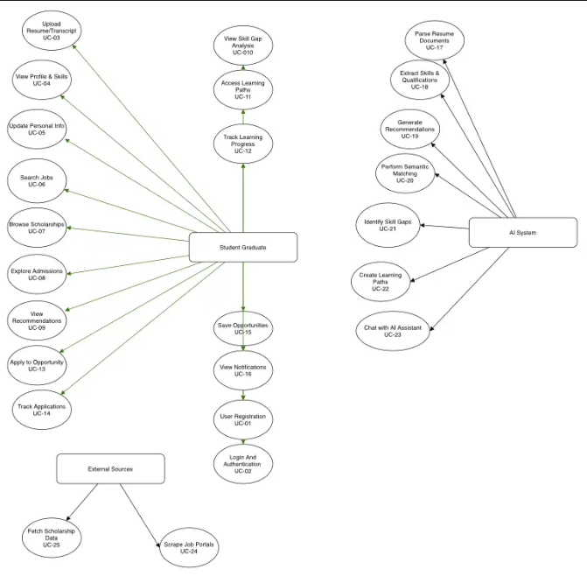

Non-functional Requirements
NextStepAI is engineered for high performance and operational reliability, mandating sub-2-second page loads and a 15-second cap on AI-driven document processing to ensure a responsive user experience for up to 100 concurrent users. To maintain stability under load, the architecture employs aggressive caching strategies, asynchronous background processing for heavy tasks, and rigorous safety protocols, including atomic database transactions, automated daily backups, and graceful degradation mechanisms that prevent system-wide failures during component outages.
Security is enforced through a comprehensive defense-in-depth approach, utilizing stateless JWT authentication, role-based access control, and strict encryption standards—TLS 1.2+ for data in transit and AES-256 for sensitive data at rest—to mitigate threats like SQL injection and CSRF attacks. This technical foundation is supported by a robust documentation framework that includes interactive user onboarding, contextual in-app help, and auto-generated API specifications, ensuring the platform remains accessible to end-users while being maintainable for future developers.

